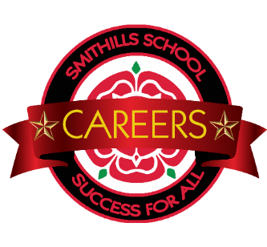
Careers Education Information Advice & Guidance
Events Calendar 2022-23
Date | Year | Activity/Event | Time
Wednesday 21st September 2022 | Y10 | Year 10 CEIAG Conference: How Employable Am I | All day
Wednesday 19th October 2022 | Year 10 | Y10 Gateways with University of Manchester  ( 12 Most able/ High achievers) | All day
Wednesday 2nd November 2022 | Year 11 | Y11 Gateways with University of Manchester  ( 12 Most able/ High achievers) | All day
Friday 18th November 2022 | Y11 | Maths Masterclass ( Wigan & Leigh ) | NEW date TBC
Monday 21st November 2022 | Y11 | B6 Coding Challenge | 12.00pm -4.30pm
Wednesday 7th December 2022 | Y9 | Year 9 CEIAG Conference: On the Right Track | All day
Friday 20th January 2023 | Y11 | Year 11 CEIAG Conference: Mock Interviews | All day
Wednesday 8th February 2023 | Year 9 | Y9 Gateways with University of Manchester  ( 12 Most able/ High achievers) | All day
Tuesday 7th February 2023 |  | Year 8 CEIAG Conference: Bright Futures & STEM
Thursday 9th February | Year 10 | Assembly: Adam Corbally ( NAW 2023) | Session Zero/Session 1
Friday 10th February 2023 | Y11 | Admission Interview ( Morning) with  The Sixth Form Bolton ( Y11) | AM ( CPD)
Monday 24th April 2023 |  | Year 7 CEIAG Conference: Unleashing my Potential
Monday 27th March -Friday 31st March 2023 | Y10 | Work Experience Week 2022 | Full week
Tuesday 23rd May 2023 | Year 7 | Y7 with University of Manchester  ( 12 Most able/ High achievers) | All day
Wednesday 10th May 2023 | Year 8 | Y8 Gateways with University of Manchester  ( 12 Most able/ High achievers) | All day
May TBA | Y11 | Visit to Bolton College ( ESOL) | PM
June TBA | Y9 | Science & Technology Challenge Day | All day
June TBA |  | Maths Masterclasses : The Sixth Form Bolton  ( Year 10) | 3.30-5.00pm
Date TBC | Year 9 | University Visit/Engagement  ( Bolton University) | Half day
Friday 7th July 2023 | Y10 | Y10 Transition Day 2022  (The Sixth Form Bolton/ Bolton College) | All day
April TBC | Y10 | (RAY) Visit to Lancaster University  (with TSFB) | Full day

This events calendar will be updated throughout the year

